For 2 papers the output is available but random. For larger corpus but not enough corpus there was no ouput i.e. end of sentence token was predominant.

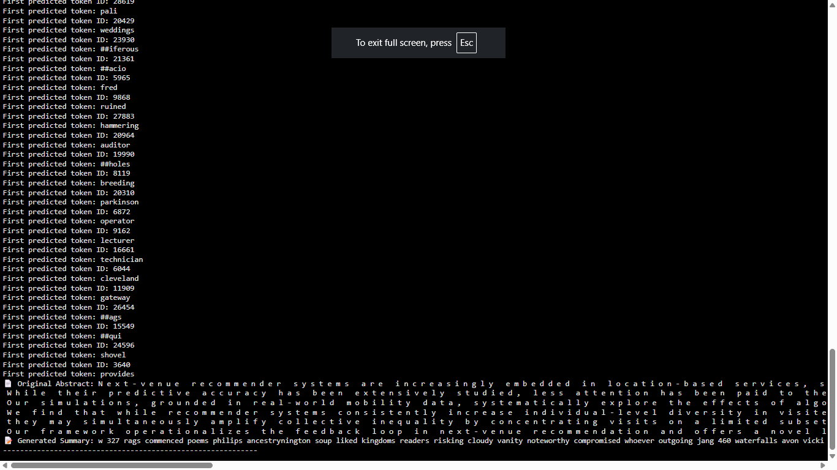

For less data but not very less 100 papers, no output as SEP is predominant.

